Care360 Gateway Installation Guide (version 1.1.0)

Also Available at:

CareValidate Commitment
CareValidate is committed to promoting worksite population health & safety per the latest scientific guidelines.

Science
Care360 is a fully integrated digital health platform that reduces the time between infection, sample collection, test resulting and isolation / quarantine. This is a scientifically validated approach that is recommended by population health experts across the globe to stop the spread of infectious agents.

Care360 Gateway
The Care360 Gateway is the network administrator for the Standalone badge. The Gateway securely connects to the Standalone badge to initiate transfer of the location tracing data for each user when the Standalone badge passes by the Gateway. The Gateway is also responsible for over-the-air (OTA) updates to the Standalone badge and for badge health (firmware version, battery life, and signal strength). The Gateway connects to the customer network via an Ethernet connection that provides Internet access and power.

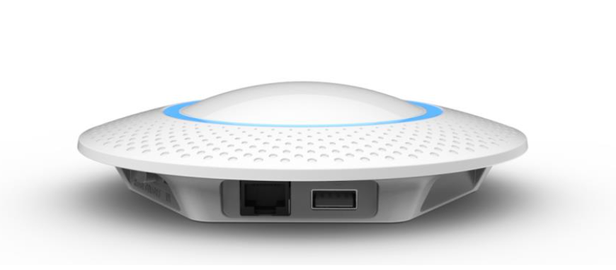

Gateway Installation Kit Contents

The Gateway is shipped with the following contents:
1 - Care360 Gateway
1 - USB Micro-B cable (power input cable if POE is not utilized)
1 - Mounting cutout
1 - Mounting screws and anchors

Connecting the Gateway
Proper function of the Care360 platform requires that the Care360 Gateway communicates with the cloud. The Ethernet port on the Gateway has been enabled with a DHCP configuration and SSL connectivity to the cloud.
- The Gateway should be mounted or placed near the ingress or egress points to each capture location. Ensure the Gateway is in a secure location (e.g. two feet above the doorway - out of reach) so it cannot be easily unplugged or pulled from the mounting location.
- Plug a CAT 5/6 cable into the Care360 Gateway. The cable should be connected to a POE enabled network switch or router with a VLAN isolated from the internal customer network.
- Press the “On/Off” button in (for on) to start the initialization process.
- The Gateway’s LED will emit multiple colors when it is powered on (see below). The power on and initialization process will take roughly 30 seconds to complete.

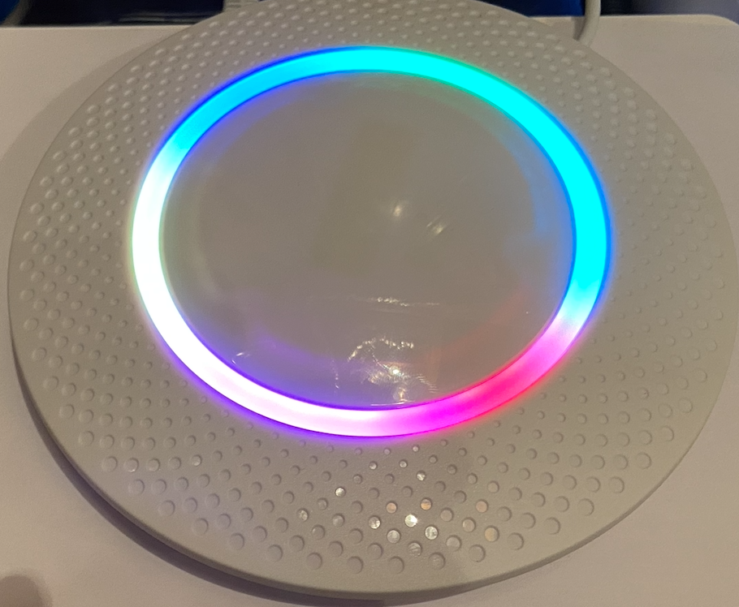

4. The Gateway LED will turn red when it is connected to a network (see below), then immediately turn green and blue (see below for the red LED).
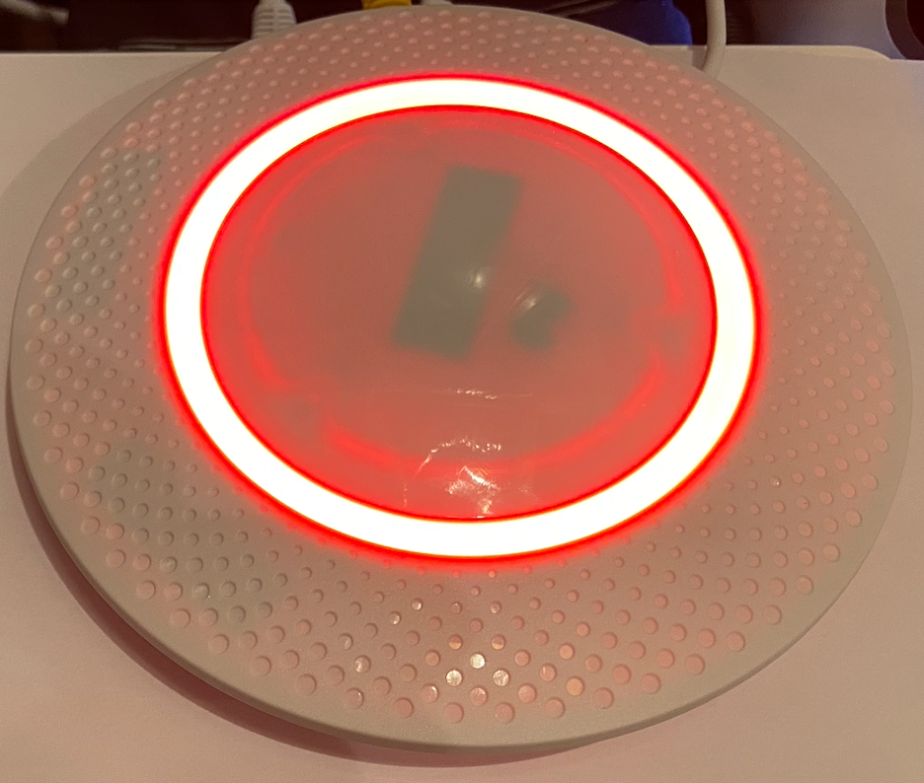

5. The gateway LED will be set to a slotted green and blue when it is connected to the Internet and a secure SSL connection is established with the cloud (see below).
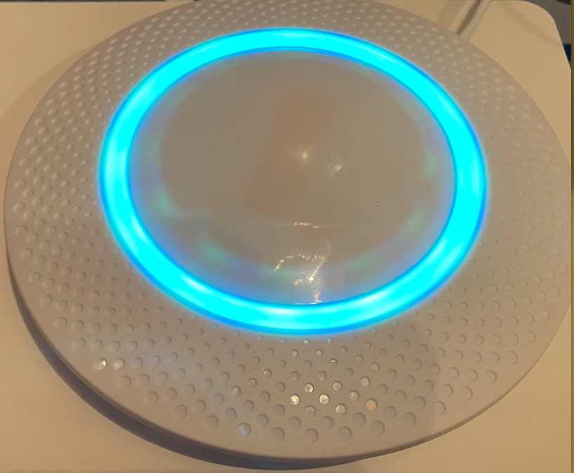

At this point the Gateway is ready to interact with Care360 Badges and capture anonymous proximity data from the Badges.
One of the primary benefits of the Care360 Gateway and Badge combination is the ease of use. Once the Gateway is online, there is nothing the employees or network administrators need to do to comply with the organization’s policies or state regulations for contact tracing. The badges will communicate with each other anonymously throughout the day, and when an employee comes into range of the Gateway, the data from the badge will be transferred to the Cloud and privately integrated into the CareValidate Care360 platform. The data transfer, from badge to cloud, occurs in the following way:

- When a Gateway detects a badge (broadcasting) in the area it will scan for the badge to make a secure connection. The LED on the gateway will turn blue (see below).
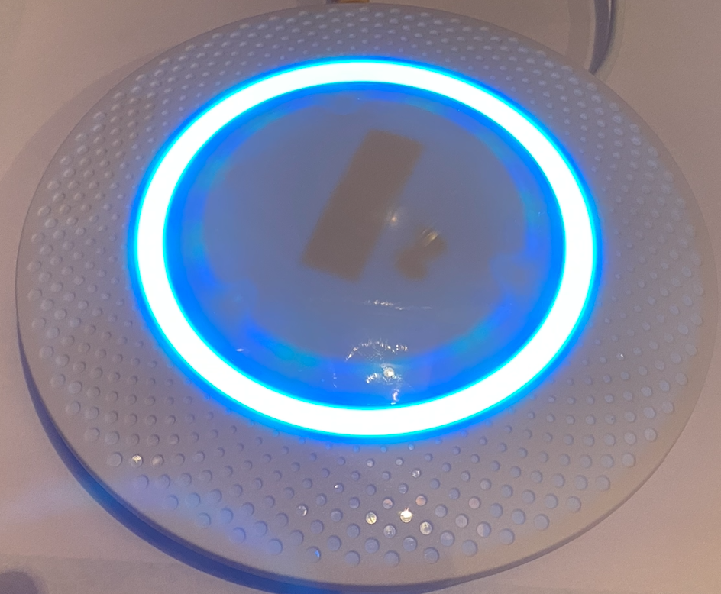

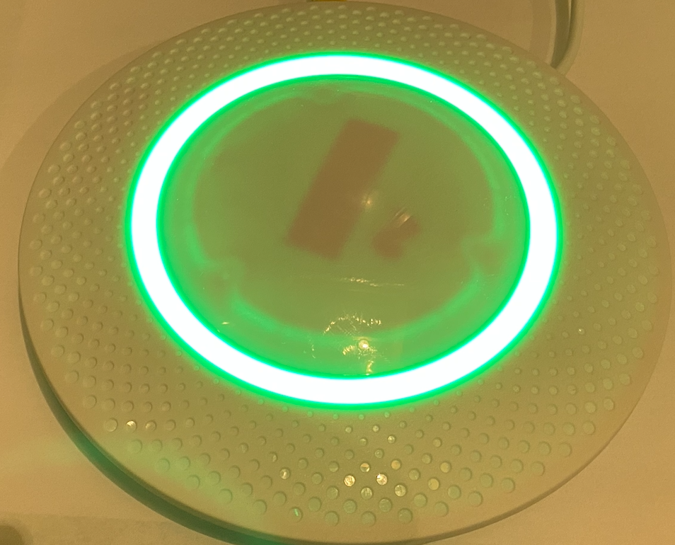
- At that point the Badge will transfer data to the Cloud and the LED will turn green when the data transfer is complete (see below). The data transfer process is very quick and there will be scores of those connections happening simultaneously on each Gateway as large numbers of employees enter and exit the building.

Mounting the Interior Gateway

The Care360 Gateway can be mounted with the help of the mounting screws and anchors provided with the gateway. A guide sticker is also provided to support an easy install.

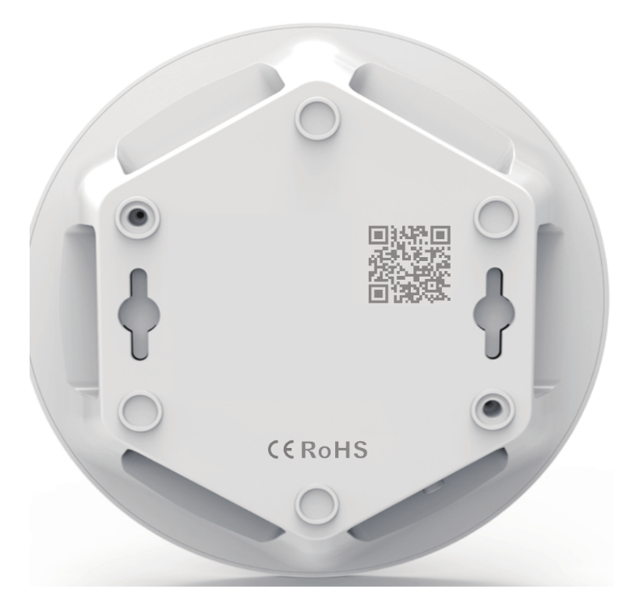

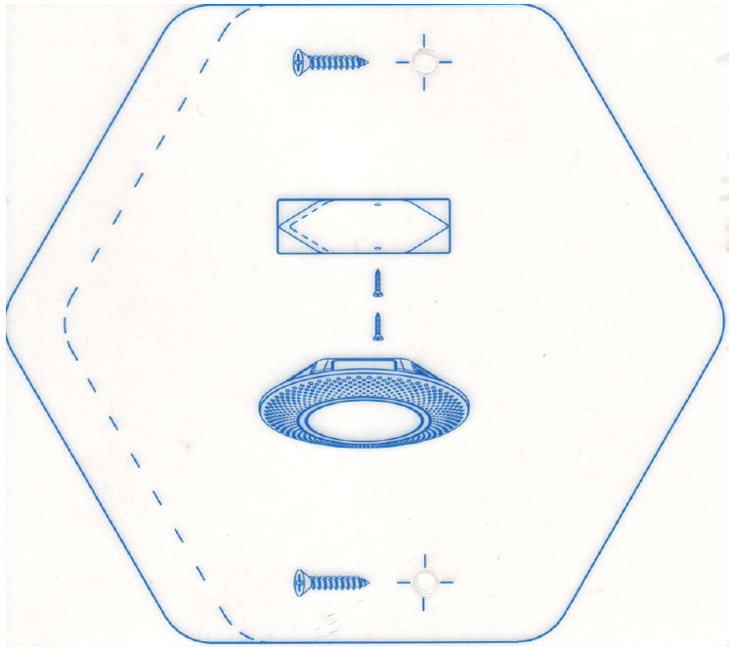

Mounting the Outdoor Gateway
The Care360 Outdoor Gateway Enclosure is designed to insulate and protect controls and components in outdoor applications. Injection molded polycarbonate thermoplastic construction with flush, solid/opaque cover. The Care360 Outdoor Gateway Enclosure has four polycarbonate feet for easy attachment to any surface when mounted outside. Cables are protected by cord grips preventing dirt dust and water to enter the enclosure. The Gateway is mounted to an aluminum back panel.
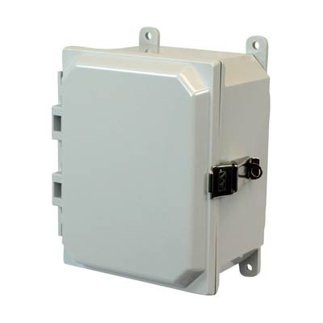

• Light weight, impact resistant and good corrosion resistance
• Protects from dirt, dust, and water
• UL 50 and UL 50E Types 1, 2, 3, 3R, 4, 4X, 12 and 13
• Complies with NEMA Types 1, 2, 3, 3R, 4, 4X, 12 and 13

Dimensions and mounting information.

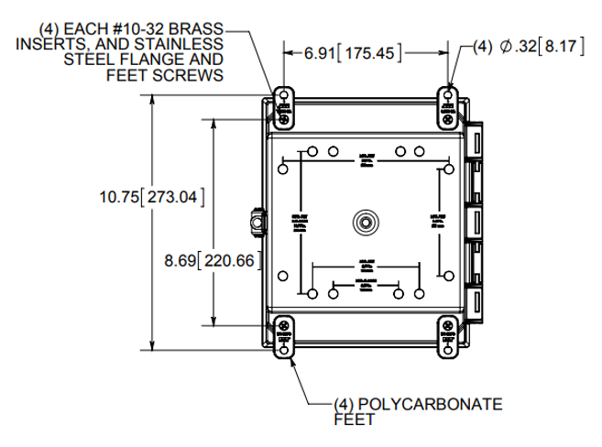

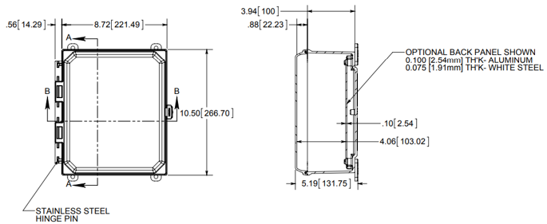

Gateway Test Plan
For training and testing please use the following test plan

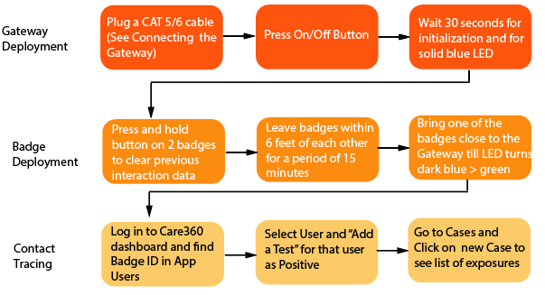

Troubleshooting

Below are some common issues you may encounter when installing the Gateway.

Question/Issue | Answer/Solution
Gateway has a POE connection, but the LED is not active. | Check the on/off switch for the Gateway. Make sure the button is pressed in (for “on”).
Gateway is plugged in and powered, but will not transition past the initialization stage (multi-colored LED). | The device is likely not receiving enough power. The Gateway requires 2.5 amps of power from the POE cable/switch to operate appropriately.
Gateway initializes but does not have a slotted green LED. | Review the firewall settings for the network the Gateway is routing through to make sure the MAC address has been whitelisted.
Gateway turns green when badges pass by but an employee’s records are not being populated in Care360. | Ensure the employee’s badge is provisioned appropriately in Care360 and mapped to the employee account.

Please contact your CareValidate customer success manager (assigned to you during on-boarding) if any of these troubleshooting steps do not resolve your issue.

